CHAPTER 2
Biological Classification
• Biological Classification

2.0 | Why Classification Systems Kept Changing

Since the dawn of civilisation, there have been many attempts to classify living organisms. It was done instinctively - not using criteria that were scientific, but borne out of a need to use organisms for our own use: for food, shelter and clothing.
• Aristotle was the earliest to attempt a more scientific basis for classification. He used simple morphological characters to classify plants into trees, shrubs and herbs. He also divided animals into two groups: those which had red blood and those that did not.
• In Linnaeus' time a Two Kingdom system of classification with Plantae and Animalia kingdoms was developed, that included all plants and animals respectively.
That two kingdom system carried a specific weakness - it did not distinguish between:
- the eukaryotes and prokaryotes,
- unicellular and multicellular organisms, and
- photosynthetic (green algae) and non-photosynthetic (fungi) organisms.
• Classification of organisms into plants and animals was easily done and was easy to understand, but a large number of organisms did not fall into either category. Hence the two kingdom classification used for a long time was found inadequate.
• Besides gross morphology, a need was also felt for including other characteristics like cell structure, nature of wall, mode of nutrition, habitat, methods of reproduction, evolutionary relationships, etc.
• Classification systems for the living organisms have hence, undergone several changes over the time. Though plant and animal kingdoms have been a constant under all different systems, the understanding of what groups/organisms be included under these kingdoms have been changing; the number and nature of other kingdoms have also been understood differently by different scientists over the time.
2.1 | Whittaker's Five Kingdom Classification

R.H. Whittaker (1969) proposed a Five Kingdom Classification. The kingdoms defined by him were named Monera, Protista, Fungi, Plantae and Animalia.
• The main criteria for classification used by him include cell structure, body organisation, mode of nutrition, reproduction and phylogenetic relationships.
• Table 2.1 gives a comparative account of different characteristics of the five kingdoms - it is the single most examinable table in this chapter.
• A three-domain system has also been proposed, that divides the Kingdom Monera into two domains, leaving the remaining eukaryotic kingdoms in the third domain, and thereby a six kingdom classification. (You will learn about this system in detail in higher classes.)
T 2.1 | Characteristics of the Five Kingdoms

Characters | Monera | Protista | Fungi | Plantae | Animalia
Cell type | Prokaryotic | Eukaryotic | Eukaryotic | Eukaryotic | Eukaryotic
Cell wall | Noncellulosic (Polysaccharide + amino acid) | Present in some | Present (with chitin) | Present (cellulose) | Absent
Nuclear membrane | Absent | Present | Present | Present | Present
Body organisation | Cellular | Cellular | Multicellular/ loose tissue | Tissue/ organ | Tissue/organ/ organ system
Mode of nutrition | Autotrophic (chemosynthetic and photosynthetic) and Heterotrophic (saprophytic/parasitic) | Autotrophic (Photosynthetic) and Heterotrophic | Heterotrophic (Saprophytic/Parasitic) | Autotrophic (Photosynthetic) | Heterotrophic (Holozoic/ Saprophytic etc.)

2.1a | What Drove the Regrouping - The 'Plants' Problem

Let us look at this five kingdom classification to understand the issues and considerations that influenced the classification system.
• Earlier classification systems included bacteria, blue green algae, fungi, mosses, ferns, gymnosperms and the angiosperms under 'Plants'. The character that unified this whole kingdom was that all the organisms included had a cell wall in their cells.
• This placed together groups which widely differed in other characteristics. It brought together the prokaryotic bacteria and the blue green algae (cyanobacteria) with other groups which were eukaryotic.
• It also grouped together the unicellular organisms and the multicellular ones - say, for example, Chlamydomonas and Spirogyra were placed together under algae.
• The classification did not differentiate between the heterotrophic group - fungi, and the autotrophic green plants, though they also showed a characteristic difference in their walls composition: the fungi had chitin in their walls while the green plants had a cellulosic cell wall.
• When such characteristics were considered, the fungi were placed in a separate kingdom - Kingdom Fungi. All prokaryotic organisms were grouped together under Kingdom Monera and the unicellular eukaryotic organisms were placed in Kingdom Protista.
• Kingdom Protista has brought together Chlamydomonas, Chlorella (earlier placed in Algae within Plants, and both having cell walls) with Paramoecium and Amoeba (which were earlier placed in the animal kingdom, which lack cell wall). Note NCERT's spelling Paramoecium (= Paramecium), used throughout this chapter.
• It has put together organisms which, in earlier classifications, were placed in different kingdoms. This happened because the criteria for classification changed. This kind of changes will take place in future too, depending on the improvement in our understanding of characteristics and evolutionary relationships.
• Over time, an attempt has been made to evolve a classification system which reflects not only the morphological, physiological and reproductive similarities, but is also phylogenetic, i.e., is based on evolutionary relationships.
[NOTE] In this chapter we will study characteristics of Kingdoms Monera, Protista and Fungi of the Whittaker system of classification. The Kingdoms Plantae and Animalia, commonly referred to as plant and animal kingdoms respectively, will be dealt separately in chapters 3 and 4 - so sections 2.4 and 2.5 below are deliberately brief in NCERT itself.

2.1 | Kingdom Monera - Bacteria

Bacteria are the sole members of the Kingdom Monera. They are the most abundant micro-organisms.
• Bacteria occur almost everywhere. Hundreds of bacteria are present in a handful of soil. The chapter summary states the same distribution fact in its own words: bacteria are cosmopolitan in distribution.
• They also live in extreme habitats such as hot springs, deserts, snow and deep oceans, where very few other life forms can survive.
• Many of them live in or on other organisms as parasites.
Bacteria are grouped under four categories based on their shape (Figure 2.1):
Shape category | Genus name (NCERT) | Plural form | Shape
Spherical | Coccus | cocci | Ball-shaped
Rod-shaped | Bacillus | bacilli | Rod
Comma-shaped | Vibrium | vibrio | Comma
Spiral | Spirillum | spirilla | Spiral/coiled

[NOTE] NCERT prints the comma-shaped genus as Vibrium (pl.: vibrio); the widely used form elsewhere is Vibrio. The NCERT spelling is kept here because the term itself is what an examination tests. Figure 2.1 labels the comma-shaped cells Vibrio.

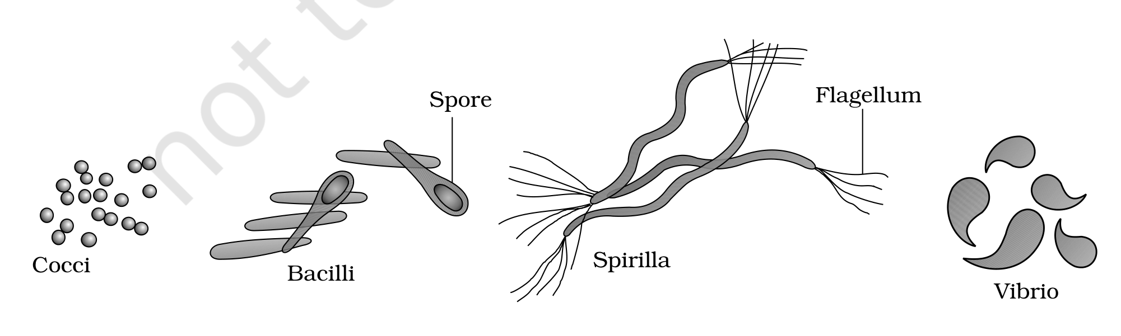
Fig. 2.1 - Bacteria of different shapes. The four shape categories are labelled Cocci (spherical), Bacilli (rod-shaped), Spirilla (spiral) and Vibrio (comma-shaped). Two further structures are labelled on the drawing: a Spore inside a bacillus, and a Flagellum - the motility structure - on the spirillum.
• Though the bacterial structure is very simple, they are very complex in behaviour. Compared to many other organisms, bacteria as a group show the most extensive metabolic diversity.
• Some of the bacteria are autotrophic, i.e., they synthesise their own food from inorganic substrates. They may be photosynthetic autotrophic or chemosynthetic autotrophic.
• The vast majority of bacteria are heterotrophs, i.e., they depend on other organisms or on dead organic matter for food.
2.1.1 | Archaebacteria

These bacteria are special since they live in some of the most harsh habitats. NCERT names three habitats, each with its own group name:
Harsh habitat | Group name
Extreme salty areas | halophiles
Hot springs | thermoacidophiles
Marshy areas | methanogens

• Archaebacteria differ from other bacteria in having a different cell wall structure, and this feature is responsible for their survival in extreme conditions.
• Methanogens are present in the gut of several ruminant animals such as cows and buffaloes, and they are responsible for the production of methane (biogas) from the dung of these animals.
[MEMORY AID - not in NCERT] Three archaebacterial habitats - 'Salt, Heat, Marsh': Halophiles = salt (halo = salt), Thermoacidophiles = hot springs (thermo = heat), Methanogens = marshy areas and ruminant gut (they generate methane).

2.1.2 | Eubacteria - 'True Bacteria'

There are thousands of different eubacteria or 'true bacteria'. They are characterised by the presence of a rigid cell wall, and if motile, a flagellum.
2.1.2a | Cyanobacteria (Blue-Green Algae)

• The cyanobacteria (also referred to as blue-green algae) have chlorophyll a similar to green plants and are photosynthetic autotrophs (Figure 2.2).
• The cyanobacteria are unicellular, colonial or filamentous, and freshwater/marine or terrestrial algae.
• The colonies are generally surrounded by gelatinous sheath. In Figure 2.2 this envelope around the filament is labelled the Mucilagenous sheath (NCERT's spelling as printed on the figure; standard form 'mucilaginous').
• They often form blooms in polluted water bodies.
• Some of these organisms can fix atmospheric nitrogen in specialised cells called heterocysts, e.g., Nostoc and Anabaena. The Heterocyst is the thick-walled cell labelled in Figure 2.2.
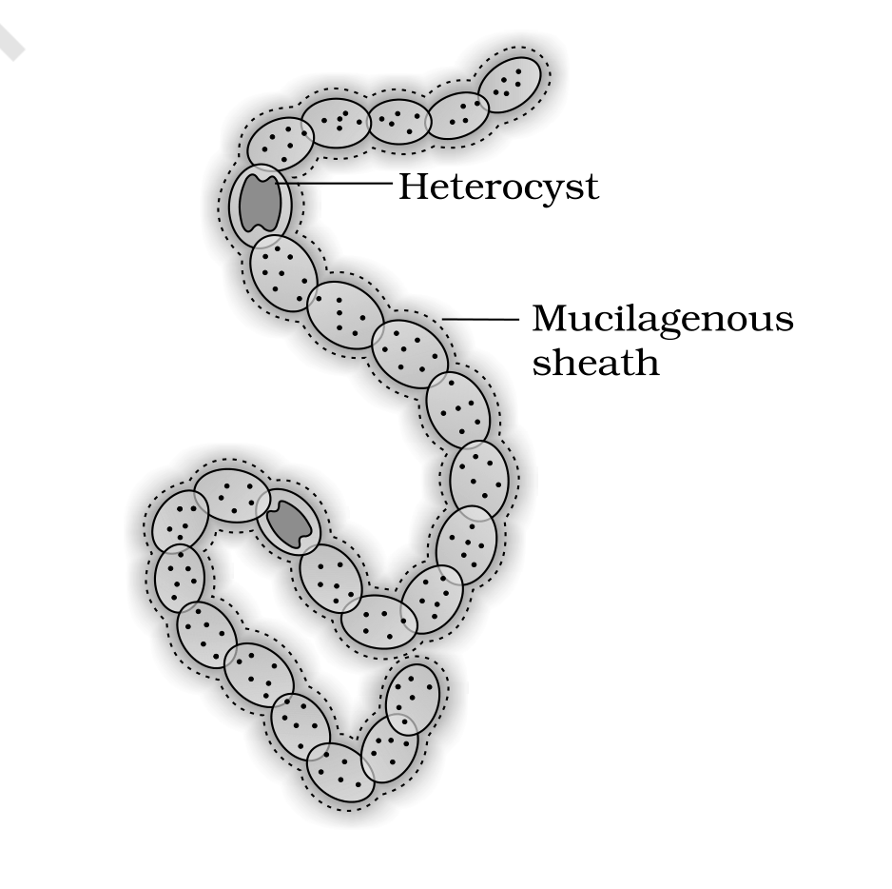
Fig. 2.2 - A filamentous blue-green algae - Nostoc. Two structures are labelled on the filament: the Heterocyst, the specialised cell in which atmospheric nitrogen is fixed, and the Mucilagenous sheath, the gelatinous envelope that generally surrounds the colony.
[NOTE] Algal bloom is the exact term Exercise 4 asks about. NCERT's body text states the phenomenon as cyanobacteria that 'often form blooms in polluted water bodies' - a rapid build-up of algal growth in a water body. Compare this with red tides (section 2.2.2), which are caused by red dinoflagellates, not by cyanobacteria.

2.1.2b | Chemosynthetic Autotrophic Bacteria

• Chemosynthetic autotrophic bacteria oxidise various inorganic substances such as nitrates, nitrites and ammonia, and use the released energy for their ATP production.
• They play a great role in recycling nutrients like nitrogen, phosphorous, iron and sulphur.
2.1.2c | Heterotrophic Bacteria

• Heterotrophic bacteria are most abundant in nature. The majority are important decomposers.
• Many of them have a significant impact on human affairs. They are helpful in making curd from milk, production of antibiotics, fixing nitrogen in legume roots, etc.
• Some are pathogens causing damage to human beings, crops, farm animals and pets. Cholera, typhoid, tetanus, citrus canker are well known diseases caused by different bacteria.
2.1.2d | Reproduction in Bacteria

• Bacteria reproduce mainly by fission (Figure 2.3).
• Sometimes, under unfavourable conditions, they produce spores.
• They also reproduce by a sort of sexual reproduction by adopting a primitive type of DNA transfer from one bacterium to the other.
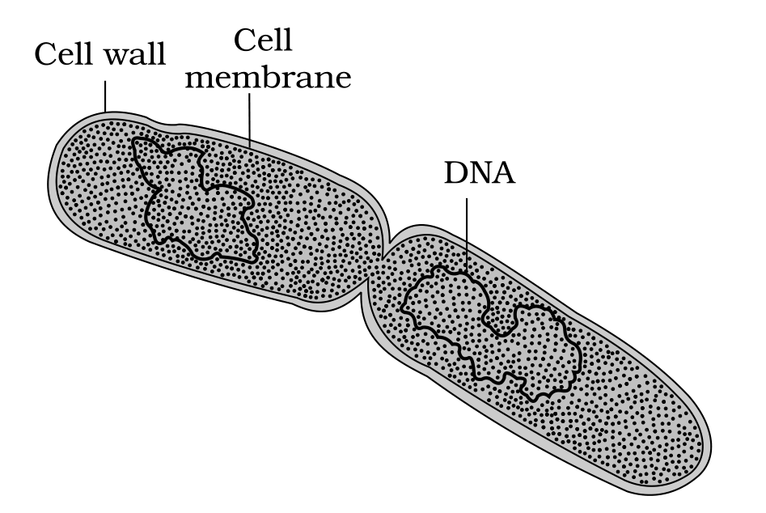
Fig. 2.3 - A dividing bacterium. Three structures are labelled: the outer Cell wall, the Cell membrane lying inside it, and the DNA - the genetic material that is copied and separated as the cell divides by fission.
2.1.2e | Mycoplasma

• The Mycoplasma are organisms that completely lack a cell wall. They are the smallest living cells known and can survive without oxygen. Many mycoplasma are pathogenic in animals and plants.
[MEMORY AID - not in NCERT] Monera extremes worth remembering: Mycoplasma = smallest living cells known + no cell wall at all + survives without oxygen; Archaebacteria = a different cell wall structure, which is what lets them survive harsh habitats. One has no wall, the other has an unusual wall.

2.2 | Kingdom Protista

All single-celled eukaryotes are placed under Protista, but the boundaries of this kingdom are not well defined. What may be 'a photosynthetic protistan' to one biologist may be 'a plant' to another.
• In this book we include Chrysophytes, Dinoflagellates, Euglenoids, Slime moulds and Protozoans under Protista.
• Members of Protista are primarily aquatic. This kingdom forms a link with the others dealing with plants, animals and fungi.
• Being eukaryotes, the protistan cell body contains a well defined nucleus and other membrane-bound organelles. Some have flagella or cilia.
• Protists reproduce asexually and sexually by a process involving cell fusion and zygote formation.
2.2.1 | Chrysophytes

• This group includes diatoms and golden algae (desmids). They are found in fresh water as well as in marine environments.
• They are microscopic and float passively in water currents (plankton). Most of them are photosynthetic.
• In diatoms the cell walls form two thin overlapping shells, which fit together as in a soap box. The walls are embedded with silica and thus the walls are indestructible.
• Thus, diatoms have left behind large amount of cell wall deposits in their habitat; this accumulation over billions of years is referred to as 'diatomaceous earth'.
• Being gritty this soil is used in polishing, filtration of oils and syrups.
• Diatoms are the chief 'producers' in the oceans.
2.2.2 | Dinoflagellates

• These organisms are mostly marine and photosynthetic.
• They appear yellow, green, brown, blue or red depending on the main pigments present in their cells.
• The cell wall has stiff cellulose plates on the outer surface.
• Most of them have two flagella; one lies longitudinally and the other transversely in a furrow between the wall plates.
• Very often, red dinoflagellates (Example: Gonyaulax) undergo such rapid multiplication that they make the sea appear red (red tides).
• Toxins released by such large numbers may even kill other marine animals such as fishes.
2.2.3 | Euglenoids

• Majority of them are fresh water organisms found in stagnant water.
• Instead of a cell wall, they have a protein rich layer called pellicle which makes their body flexible.
• They have two flagella, a short and a long one.
• Though they are photosynthetic in the presence of sunlight, when deprived of sunlight they behave like heterotrophs by predating on other smaller organisms.
• Interestingly, the pigments of euglenoids are identical to those present in higher plants. Example: Euglena (Figure 2.4b).
2.2.4 | Slime Moulds

• Slime moulds are saprophytic protists. The body moves along decaying twigs and leaves engulfing organic material.
• Under suitable conditions, they form an aggregation called plasmodium which may grow and spread over several feet.
• During unfavourable conditions, the plasmodium differentiates and forms fruiting bodies bearing spores at their tips.
• The spores possess true walls. They are extremely resistant and survive for many years, even under adverse conditions. The spores are dispersed by air currents.
2.2.5 | Protozoans - The Four Major Groups

• All protozoans are heterotrophs and live as predators or parasites. They are believed to be primitive relatives of animals.
There are four major groups of protozoans.
Group | Locomotion / key structure | Habitat and nutrition | NCERT examples
Amoeboid protozoans | Move and capture prey by putting out pseudopodia (false feet) | Live in fresh water, sea water or moist soil; marine forms have silica shells on their surface | Amoeba; Entamoeba (a parasite)
Flagellated protozoans | They have flagella | Either free-living or parasitic; the parasitic forms cause diseases such as sleeping sickness | Trypanosoma
Ciliated protozoans | Thousands of cilia; a cavity (gullet) that opens to the outside of the cell surface. Coordinated movement of rows of cilia steers water laden with food into the gullet | Aquatic, actively moving organisms | Paramoecium (Figure 2.4d)
Sporozoans | Have an infectious spore-like stage in their life cycle | Diverse organisms; the most notorious causes malaria, a disease which has a staggering effect on human population | Plasmodium (malarial parasite)

[NOTE] NCERT prints 'diaseases' in the flagellated-protozoans sentence ('The parasitic forms cause diaseases such as sleeping sickness'). This is a typographical slip in the source and is written as diseases in the table above; the fact itself is unchanged.

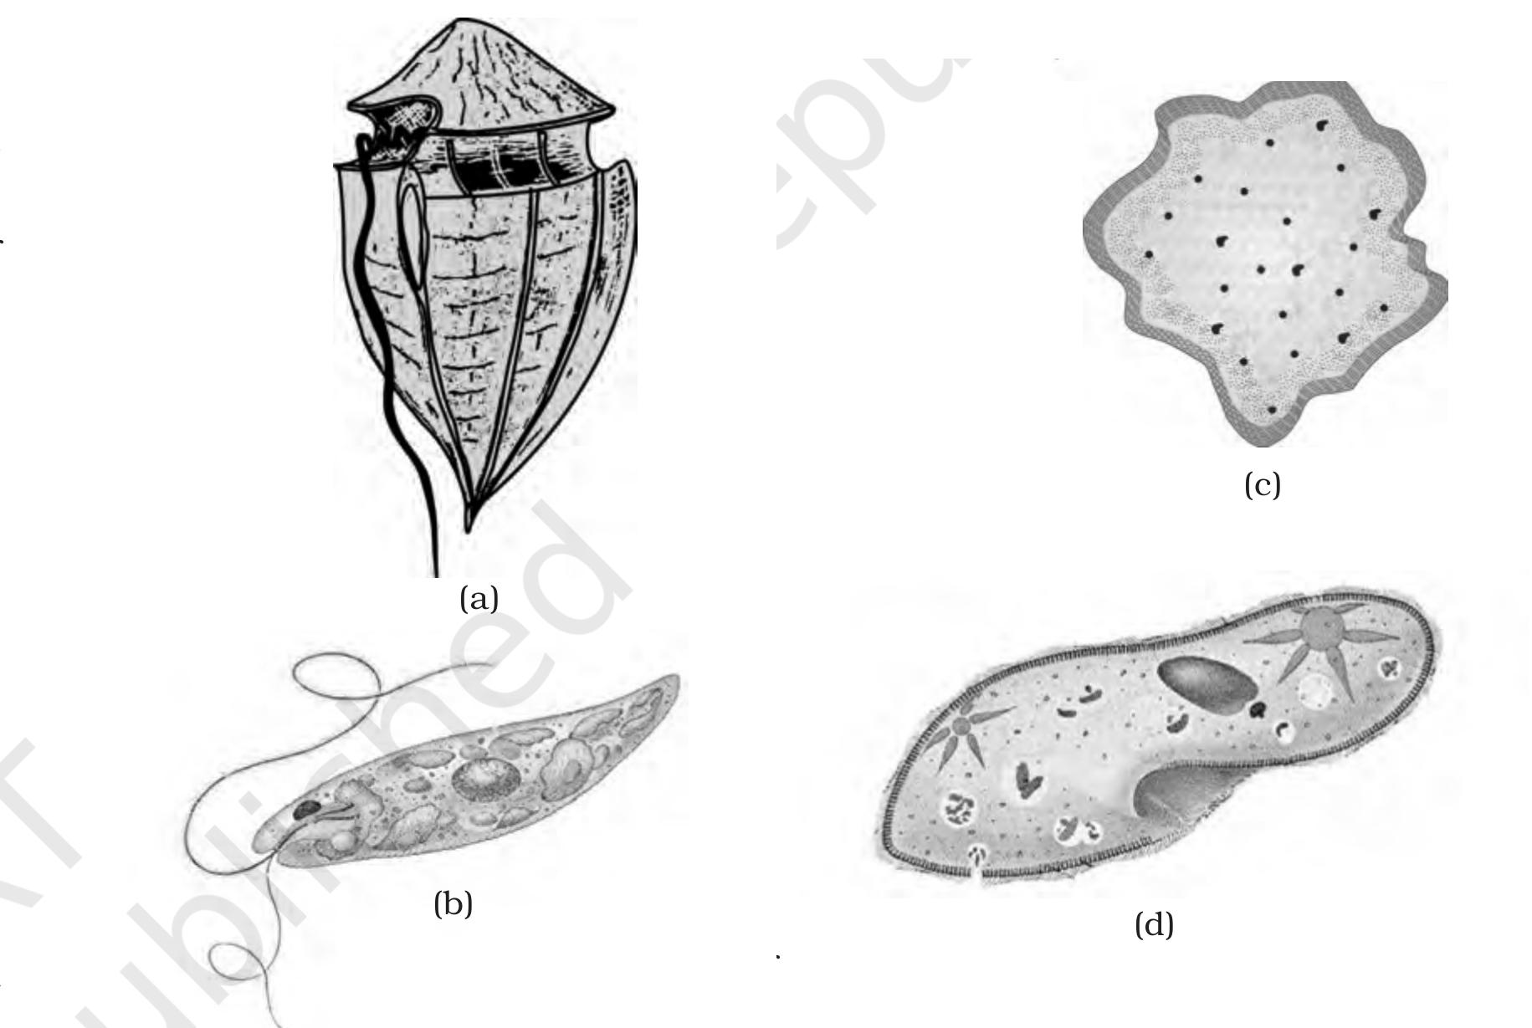
Fig. 2.4 - Representative protists: (a) Dinoflagellates, (b) Euglena, (c) Slime mould, (d) Paramoecium. The four drawings carry only the panel markers panel (a), panel (b), panel (c) and panel (d); each organism is identified by this caption. Dinoflagellates in panel (a) appear yellow, green, brown, blue or red in life depending on their main pigments - that colour difference cannot be shown in a monochrome print, so it is stated here in words.
2.3 | Kingdom Fungi

• The fungi constitute a unique kingdom of heterotrophic organisms. They show a great diversity in morphology and habitat.
Where you have already met fungi, in NCERT's own examples:
- On a moist bread and rotten fruits.
- The common mushroom you eat and toadstools are also fungi.
- White spots seen on mustard leaves are due to a parasitic fungus.
- Some unicellular fungi, e.g., yeast, are used to make bread and beer.
- Other fungi cause diseases in plants and animals; wheat rust-causing Puccinia is an important example.
- Some are the source of antibiotics, e.g., Penicillium.
• Fungi are cosmopolitan and occur in air, water, soil and on animals and plants. They prefer to grow in warm and humid places.
[NOTE] This is where NCERT uses the word cosmopolitan - it is applied to fungi here, and the chapter summary applies it to bacteria as well (see Kingdom Monera). Keep the term attached to both in your recall, but note that the body text says of bacteria only that they occur almost everywhere.

• This is also why we keep food in the refrigerator - to prevent food from going bad due to bacterial or fungal infections.
2.3a | Structure of the Fungal Body

• With the exception of yeasts which are unicellular, fungi are filamentous.
• Their bodies consist of long, slender thread-like structures called hyphae. The network of hyphae is known as mycelium.
• Two kinds of hyphae are distinguished:
- Coenocytic hyphae - some hyphae are continuous tubes filled with multinucleated cytoplasm.
- Others have septae or cross walls in their hyphae.
• The cell walls of fungi are composed of chitin and polysaccharides.
[MEMORY AID - not in NCERT] Cell-wall chemistry across the kingdoms, in one line: Monera = noncellulosic (polysaccharide + amino acid), Fungi = chitin + polysaccharides, Plantae = cellulose, Animalia = no cell wall. Only the fungal wall carries chitin.

2.3b | Modes of Nutrition

• Most fungi are heterotrophic and absorb soluble organic matter from dead substrates and hence are called saprophytes. Stated the short way, as the chapter summary puts it: most fungi are saprophytic in their mode of nutrition.
• Those that depend on living plants and animals are called parasites.
• They can also live as symbionts - in association with algae as lichens and with roots of higher plants as mycorrhiza.
[NOTE] The lichen partnership named here is taken up in full in section 2.6 of this chapter, where the algal partner is named phycobiont and the fungal partner mycobiont.

2.3c | Reproduction in Fungi

• Reproduction in fungi can take place by vegetative means - fragmentation, fission and budding.
• Asexual reproduction is by spores called conidia or sporangiospores or zoospores, and sexual reproduction is by oospores, ascospores and basidiospores.
• The various spores are produced in distinct structures called fruiting bodies.
The sexual cycle involves the following three steps:
1 | Plasmogamy - fusion of protoplasms between two motile or non-motile gametes.
2 | Karyogamy - fusion of two nuclei.
3 | Meiosis in zygote, resulting in haploid spores.

• When a fungus reproduces sexually, two haploid hyphae of compatible mating types come together and fuse. What happens next differs between groups:
- In some fungi the fusion of two haploid cells immediately results in diploid cells (2n).
- However, in other fungi (ascomycetes and basidiomycetes), an intervening dikaryotic stage (n + n, i.e., two nuclei per cell) occurs; such a condition is called a dikaryon and the phase is called dikaryophase of fungus.
• Later, the parental nuclei fuse and the cells become diploid. The fungi form fruiting bodies in which reduction division occurs, leading to formation of haploid spores.
• The morphology of the mycelium, mode of spore formation and fruiting bodies form the basis for the division of the kingdom into various classes.
[MEMORY AID - not in NCERT] The two-step nuclear sequence never changes: plasmogamy before karyogamy - cytoplasms first, nuclei second. The dikaryon (n + n) is what sits between them in ascomycetes and basidiomycetes.

2.3.1 | Phycomycetes

• Found in aquatic habitats and on decaying wood in moist and damp places or as obligate parasites on plants.
• The mycelium is aseptate and coenocytic.
• Asexual reproduction takes place by zoospores (motile) or by aplanospores (non-motile). These spores are endogenously produced in sporangium.
• A zygospore is formed by fusion of two gametes. These gametes are similar in morphology (isogamous) or dissimilar (anisogamous or oogamous).
• Some common examples are Mucor (Figure 2.5a), Rhizopus (the bread mould mentioned earlier) and Albugo (the parasitic fungi on mustard).
[NOTE] Albugo closes the loop on the white spots on mustard leaves mentioned at the start of this kingdom, and Rhizopus is the mould on the moist bread. Aplanospores are non-motile and zoospores are motile - the distinction is asked for directly.

2.3.2 | Ascomycetes

• Commonly known as sac-fungi, the ascomycetes are mostly multicellular, e.g., Penicillium, or rarely unicellular, e.g., yeast (Saccharomyces).
• They are saprophytic, decomposers, parasitic or coprophilous (growing on dung). Mycelium is branched and septate.
• The asexual spores are conidia produced exogenously on the special mycelium called conidiophores. Conidia on germination produce mycelium.
• Sexual spores are called ascospores which are produced endogenously in sac like asci (singular ascus). These asci are arranged in different types of fruiting bodies called ascocarps.
• Some examples are Aspergillus (Figure 2.5b), Claviceps and Neurospora. Neurospora is used extensively in biochemical and genetic work.
• Many members like morels and truffles are edible and are considered delicacies.
[MEMORY AID - not in NCERT] Conidia = exogenous (outside, on conidiophores); ascospores = endogenous (inside the sac-like ascus). Sac-fungi keep their sexual spores in a sac.

2.3.3 | Basidiomycetes

• Commonly known forms of basidiomycetes are mushrooms, bracket fungi or puffballs.
• They grow in soil, on logs and tree stumps and in living plant bodies as parasites, e.g., rusts and smuts. The mycelium is branched and septate.
• The asexual spores are generally not found, but vegetative reproduction by fragmentation is common.
• The sex organs are absent, but plasmogamy is brought about by fusion of two vegetative or somatic cells of different strains or genotypes.
• The resultant structure is dikaryotic which ultimately gives rise to basidium. Karyogamy and meiosis take place in the basidium producing four basidiospores.
• The basidiospores are exogenously produced on the basidium (pl.: basidia). The basidia are arranged in fruiting bodies called basidiocarps.
• Some common members are Agaricus (mushroom) (Figure 2.5c), Ustilago (smut) and Puccinia (rust fungus).
[MEMORY AID - not in NCERT] Basidiomycetes are the group defined by absences and a fixed number: no asexual spores, no sex organs, but exactly four basidiospores per basidium, produced exogenously. Fruiting body = basidiocarp (compare ascocarp in ascomycetes).

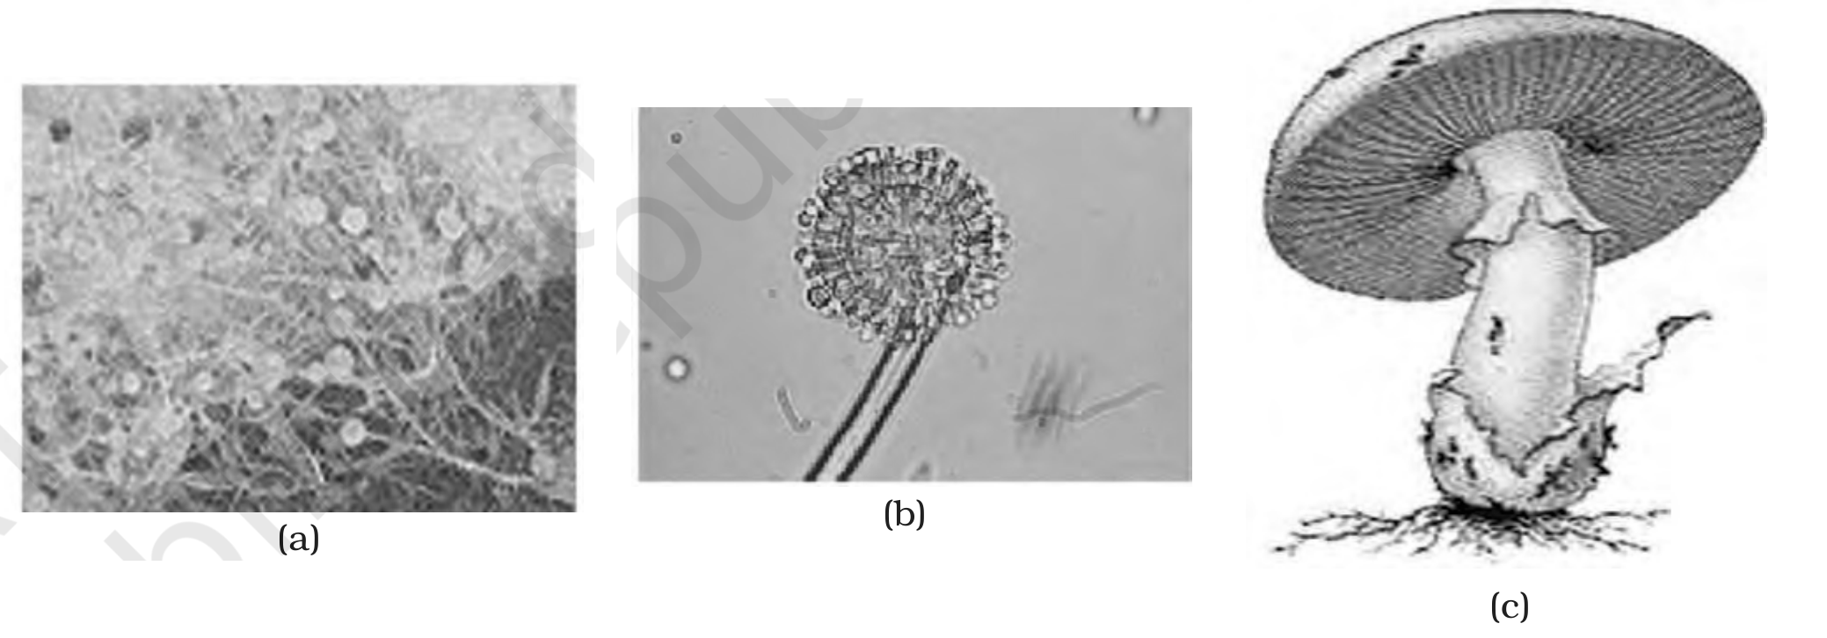
Fig. 2.5 - Fungi: (a) Mucor, (b) Aspergillus, (c) Agaricus. The three drawings carry only the panel markers (a), (b) and (c); each fungus is identified by this caption. One representative is drawn per class discussed above - Mucor for the Phycomycetes, Aspergillus for the Ascomycetes and Agaricus, the mushroom, for the Basidiomycetes.
2.3.4 | Deuteromycetes

• Commonly known as imperfect fungi because only the asexual or vegetative phases of these fungi are known.
• When the sexual forms of these fungi were discovered they were moved into classes they rightly belong to.
• The reason such a holding class was needed at all: the asexual or vegetative stage of a fungus could be given one name and placed under the deuteromycetes, while its sexual stage carried another name; once the linkages between the two stages were established, the fungi were correctly identified and moved out of the deuteromycetes.
• Once perfect (sexual) stages of members of deuteromycetes were discovered, they were often moved to ascomycetes and basidiomycetes.
• The deuteromycetes reproduce only by asexual spores known as conidia. The mycelium is septate and branched.
• Some members are saprophytes or parasites while a large number of them are decomposers of litter and help in mineral cycling.
• Some examples are Alternaria, Colletotrichum and Trichoderma.
[NOTE] NCERT prints the class name as dueteromycetes in the sentence about perfect stages being discovered, and deuteromycetes everywhere else. The typo is normalised to deuteromycetes in the prose above, per the source-spelling policy recorded at the top of these notes.

T 2.2 | The Four Classes of Fungi Compared

Class | Habitat / nutrition | Mycelium | Asexual reproduction | Sexual reproduction | Examples
Phyco-  mycetes | Aquatic habitats, on decaying wood in moist and damp places, or obligate parasites on plants | Aseptate and coenocytic | Zoospores (motile) or aplanospores (non-motile), produced endogenously in sporangium | Zygospore by fusion of two gametes - isogamous, or anisogamous or oogamous | Mucor, Rhizopus, Albugo
Asco-  mycetes  (sac-fungi) | Saprophytic, decomposers, parasitic or coprophilous (growing on dung) | Branched and septate | Conidia, produced exogenously on conidiophores; conidia on germination produce mycelium | Ascospores, produced endogenously in sac-like asci; asci arranged in ascocarps | Penicillium, yeast (Saccharomyces), Aspergillus, Claviceps, Neurospora
Basidio-  mycetes | Grow in soil, on logs and tree stumps and in living plant bodies as parasites (rusts and smuts) | Branched and septate | Generally not found; vegetative reproduction by fragmentation is common | Sex organs absent; plasmogamy by fusion of two vegetative or somatic cells of different strains; dikaryotic structure gives rise to basidium, which produces four basidiospores exogenously; basidia in basidiocarps | Agaricus (mushroom), Ustilago (smut), Puccinia (rust fungus)
Deutero-  mycetes  (imperfect fungi) | Saprophytes or parasites; a large number are decomposers of litter and help in mineral cycling | Septate and branched | Only asexual spores known as conidia | Only the asexual or vegetative phases are known; when the perfect (sexual) stage was discovered, members were moved to ascomycetes and basidiomycetes | Alternaria, Colletotrichum, Trichoderma

2.4 | Kingdom Plantae

• Kingdom Plantae includes all eukaryotic chlorophyll-containing organisms commonly called plants.
• A few members are partially heterotrophic such as the insectivorous plants or parasites. Bladderwort and Venus fly trap are examples of insectivorous plants and Cuscuta is a parasite.
• The plant cells have an eukaryotic structure with prominent chloroplasts and cell wall mainly made of cellulose. The cell structure itself is described in Chapter 8.
• Plantae includes algae, bryophytes, pteridophytes, gymnosperms and angiosperms.
• Life cycle of plants has two distinct phases - the diploid sporophytic and the haploid gametophytic - that alternate with each other. The lengths of the haploid and diploid phases, and whether these phases are free-living or dependent on others, vary among different groups in plants. This phenomenon is called alternation of generations. Further details are taken up in Chapter 3.
[NOTE] Note the exact qualifier NCERT uses: plants are chlorophyll-containing and autotrophic as a rule, but a few members are partially heterotrophic - the insectivorous plants and the parasites. Partially is the operative word; they are not moved out of Plantae.

[MEMORY AID - not in NCERT] Five groups inside Plantae, in the order NCERT lists them: Algae, Bryophytes, Pteridophytes, Gymnosperms, Angiosperms. Two partially heterotrophic examples to hold ready: Bladderwort and Venus fly trap (insectivorous), Cuscuta (parasite).

2.5 | Kingdom Animalia

• This kingdom is characterised by heterotrophic eukaryotic organisms that are multicellular and their cells lack cell walls.
• They directly or indirectly depend on plants for food. They digest their food in an internal cavity and store food reserves as glycogen or fat.
• Their mode of nutrition is holozoic - by ingestion of food.
• They follow a definite growth pattern and grow into adults that have a definite shape and size. Higher forms show elaborate sensory and neuromotor mechanism. Most of them are capable of locomotion.
• The sexual reproduction is by copulation of male and female followed by embryological development. The salient features of the various animal phyla are described in Chapter 4.
[MEMORY AID - not in NCERT] The four defining words for Animalia: heterotrophic, eukaryotic, multicellular, no cell wall. Storage is glycogen or fat (not starch), digestion is in an internal cavity, and nutrition is holozoic - by ingestion.

2.6 | Viruses, Viroids, Prions and Lichens

• In the five kingdom classification of Whittaker there is no mention of lichens and some acellular organisms like viruses, viroids and prions. All four are briefly introduced here. Note NCERT's own grouping: the acellular agents are the viruses, viroids and prions; a lichen is not acellular - it is a cellular association of an alga and a fungus (section 2.6d), left out of the five kingdoms for a different reason.
• Viruses did not find a place in classification since they are not considered truly 'living', if we understand living as those organisms that have a cell structure.
• All of us who have suffered the ill effects of common cold or 'flu' know what effects viruses can have on us, even if we do not associate it with our condition.
2.6a | Viruses

• The viruses are non-cellular organisms that are characterised by having an inert crystalline structure outside the living cell. Once they infect a cell, they take over the machinery of the host cell to replicate themselves, killing the host.
• Virus means venom or poisonous fluid.
How the virus was discovered - the three names NCERT fixes:
1 | Dmitri Ivanowsky (1892) recognised certain microbes as causal organism of the mosaic disease of tobacco (Figure 2.6a). These were found to be smaller than bacteria because they passed through bacteria-proof filters.
2 | M.W. Beijerinck (1898) demonstrated that the extract of the infected plants of tobacco could cause infection in healthy plants and named the new pathogen 'virus' and called the fluid as Contagium vivum fluidum (infectious living fluid).
3 | W.M. Stanley (1935) showed that viruses could be crystallised and crystals consist largely of proteins. They are inert outside their specific host cell. Viruses are obligate parasites.

• In addition to proteins, viruses also contain genetic material, that could be either RNA or DNA. No virus contains both RNA and DNA. A virus is a nucleoprotein and the genetic material is infectious.
Virus group | Genetic material as stated by NCERT
Viruses that infect plants | Single stranded RNA
Viruses that infect animals | Either single or double stranded RNA or double stranded DNA
Bacterial viruses or bacteriophages (viruses that infect the bacteria) - Figure 2.6b | Usually double stranded DNA viruses

[NOTE] The table above is prefaced in the source by In general - keep that qualifier. The absolute statement is the other one: no virus contains both RNA and DNA.

• The protein coat called capsid made of small subunits called capsomeres, protects the nucleic acid. These capsomeres are arranged in helical or polyhedral geometric forms.
• Viruses cause diseases like mumps, small pox, herpes and influenza. AIDS in humans is also caused by a virus.
• In plants, the symptoms can be mosaic formation, leaf rolling and curling, yellowing and vein clearing, dwarfing and stunted growth.
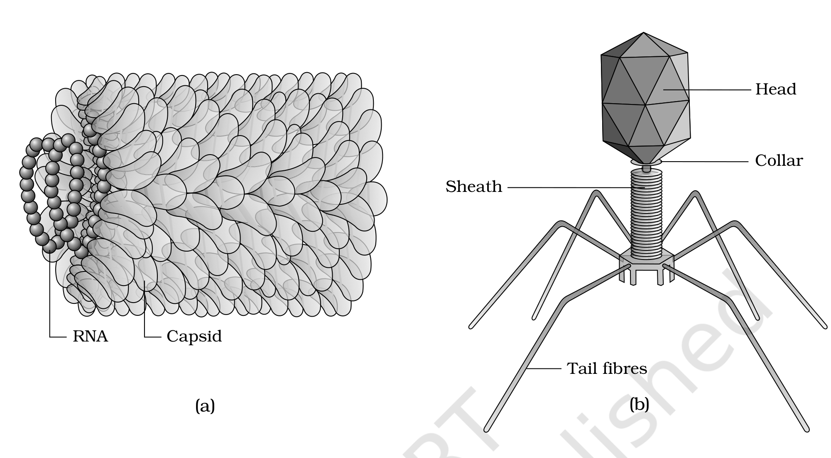
Fig. 2.6 - (a) Tobacco Mosaic Virus (TMV), (b) Bacteriophage. In panel (a) the two labelled parts of the TMV particle are its RNA and the surrounding protein Capsid. In panel (b) the bacteriophage is labelled Head, Collar, Sheath and Tail fibres. In the source artwork the phage head is printed in a different colour from the tail, sheath and collar; in this monochrome print the parts are told apart by their labels and position instead of by colour.
[MEMORY AID - not in NCERT] Four viral diseases of humans to name on demand: mumps, small pox, herpes, influenza (and AIDS). Plant symptoms: mosaic formation, leaf rolling and curling, yellowing and vein clearing, dwarfing and stunted growth.

[NOTE] Would you call viruses living or non-living? - the chapter puts this question to you directly, and gives you both sides rather than a verdict: viruses are not considered truly 'living' if living means having a cell structure, and they are inert crystalline structures outside the living cell; yet they carry infectious genetic material and, once inside a host cell, take over its machinery to replicate. Answer it with these facts, not with a one-word label.

2.6b | Viroids

• In 1971, T.O. Diener discovered a new infectious agent that was smaller than viruses and caused potato spindle tuber disease. It was found to be a free RNA; it lacked the protein coat that is found in viruses, hence the name viroid. The RNA of the viroid was of low molecular weight.
[MEMORY AID - not in NCERT] Viroid against virus, in three strokes: smaller than viruses, free RNA with no protein coat (no capsid), RNA of low molecular weight. Disease to remember: potato spindle tuber disease.

2.6c | Prions

• In modern medicine, certain infectious neurological diseases were found to be transmitted by an agent consisting of abnormally folded protein. The agent was similar in size to viruses. These agents were called prions.
• The most notable diseases caused by prions are bovine spongiform encephalopathy (BSE) commonly called mad cow disease in cattle and its analogous variant Creutzfeldt-Jacob disease (CJD) in humans.
[MEMORY AID - not in NCERT] The three acellular agents differ by what carries the infection: virus = nucleoprotein (RNA or DNA inside a capsid), viroid = free RNA (no coat), prion = abnormally folded protein (no nucleic acid at all). Prion diseases: BSE in cattle, CJD in humans.

2.6d | Lichens

• Lichens are symbiotic associations i.e. mutually useful associations, between algae and fungi. The algal component is known as phycobiont and fungal component as mycobiont, which are autotrophic and heterotrophic, respectively.
• Algae prepare food for fungi and fungi provide shelter and absorb mineral nutrients and water for its partner.
• So close is their association that if one saw a lichen in nature one would never imagine that they had two different organisms within them.
• Lichens are very good pollution indicators - they do not grow in polluted areas.
[MEMORY AID - not in NCERT] Phycobiont = the alga = autotrophic = makes the food. Mycobiont = the fungus = heterotrophic = gives shelter and absorbs mineral nutrients and water. Lichens are very good pollution indicators because they do not grow in polluted areas.

Recap | Quick Recap

• Biological classification was first proposed by Aristotle on the basis of simple morphological characters. Linnaeus later classified all living organisms into two kingdoms - Plantae and Animalia.
• Whittaker proposed a five kingdom classification - Monera, Protista, Fungi, Plantae and Animalia. The main criteria were cell structure, body organisation, mode of nutrition and reproduction, and phylogenetic relationships. This kind of changes will take place in future too depending on the improvement in our understanding of characteristics and evolutionary relationships.
• Bacteria are included in Kingdom Monera. Bacteria are cosmopolitan in distribution. They show the most extensive metabolic diversity and may be autotrophic or heterotrophic in their mode of nutrition.
• Kingdom Protista includes single-celled eukaryotes - Chrysophytes, Dinoflagellates, Euglenoids, Slime-moulds and Protozoans. Protists have a defined nucleus and other membrane-bound organelles, and they reproduce both asexually and sexually.
• Fungi show a great diversity in structures and habitat, reproduce both asexually and sexually, and are divided into four classes - Phycomycetes, Ascomycetes, Basidiomycetes and Deuteromycetes. Most fungi are saprophytic in their mode of nutrition.
• Kingdom Plantae includes all eukaryotic chlorophyll-containing organisms, namely algae, bryophytes, pteridophytes, gymnosperms and angiosperms, and their life cycle shows alternation of generations between a diploid sporophytic and a haploid gametophytic phase.
• Kingdom Animalia is characterised by heterotrophic, eukaryotic, multicellular organisms whose cells lack cell walls, and their mode of nutrition is holozoic.
• Viruses, viroids, prions and lichens find no mention in the five kingdom classification. A virus is a non-cellular nucleoprotein with either RNA or DNA, never both; a viroid is free RNA of low molecular weight without a protein coat; a prion is an abnormally folded protein; and a lichen is a symbiotic association between an algal phycobiont and a fungal mycobiont.
Appendix | Terms Used in the Exercises

These exercise questions lean on points the chapter body assumes rather than states outright. Each answer below is assembled only from facts stated in this chapter.
• Why classification systems keep changing (Q1). The earlier classifications included bacteria, blue-green algae, fungi, mosses, ferns, gymnosperms and the angiosperms under 'Plants', so groups which widely differed in other characteristics were placed together because a single character - the cell wall - was used. Once cell structure, nature of wall, mode of nutrition, habitat, methods of reproduction and evolutionary relationships were considered, the fungi were placed in a separate Kingdom Fungi and the prokaryotes were separated from the eukaryotes. The chapter states plainly that this kind of changes will take place in future too depending on the improvement in our understanding of characteristics and evolutionary relationships.
• Economic uses of bacteria and archaebacteria (Q2). Among the heterotrophic bacteria, the helpful ones are those that make curd from milk, produce antibiotics and fix nitrogen in legume roots. Among the archaebacteria, the methanogens live in the gut of several ruminant animals such as cows and buffaloes and are responsible for the production of methane (biogas) from the dung of these animals.
• The nature of the cell wall in diatoms (Q3). In the chrysophytes, the cell walls form two thin overlapping shells, which fit together as in a soap box. The walls are embedded with silica and so are indestructible. That indestructibility is why diatoms have left behind large amounts of cell wall deposits in their habitat, an accumulation called diatomaceous earth, which is gritty and is used in polishing and in the filtration of oils and syrups.
• 'Algal bloom' and 'red tides' (Q4). The chapter never prints the phrase algal bloom, but it supplies the fact behind it: blue-green algae (cyanobacteria) form blooms in polluted water bodies - a bloom is that visible mass multiplication in the water. Red tides is the chapter's own term, used of the dinoflagellates: red dinoflagellates (e.g., Gonyaulax) undergo such rapid multiplication that they make the sea appear red (red tides). So a bloom is the general event, and a red tide is the specific case caused by red dinoflagellates.
• Viroids against viruses (Q5). A virus has genetic material - either RNA or DNA, never both - enclosed in a protein coat (capsid) of capsomeres, i.e. it is a nucleoprotein. A viroid, discovered by T.O. Diener in 1971, is smaller than a virus, consists of free RNA and lacks the protein coat that is found in viruses - that missing coat is the reason for the name - and its RNA is of low molecular weight. It caused potato spindle tuber disease.
• The four major groups of Protozoa (Q6). Amoeboid protozoans (move and capture prey by pseudopodia; Amoeba, and the parasitic Entamoeba), flagellated protozoans (have flagella; the parasitic Trypanosoma causes sleeping sickness), ciliated protozoans (have thousands of cilia and a cavity (gullet); Paramoecium) and sporozoans (have an infectious spore-like stage; Plasmodium causes malaria). All protozoans are heterotrophs and live as predators or parasites, and they are believed to be primitive relatives of animals.
• Partially heterotrophic plants (Q7). Plantae is defined by chlorophyll-containing eukaryotes, but a few members are partially heterotrophic: the insectivorous plants - Bladderwort and Venus fly trap - and the parasites, of which the chapter's example is Cuscuta.
• Phycobiont and mycobiont (Q8). These are the two partners in a lichen, a symbiotic, i.e. mutually useful, association between algae and fungi. The phycobiont is the algal component and is autotrophic - it prepares food for the fungi. The mycobiont is the fungal component and is heterotrophic - it provides shelter and absorbs mineral nutrients and water for its partner.
• Comparative account of the fungal classes (Q9). Answered in full by Table T 2.2 above, which sets the habitat and nutrition, mycelium, asexual reproduction, sexual reproduction and examples of the Phycomycetes, Ascomycetes, Basidiomycetes and Deuteromycetes side by side.
• Characteristic features of Euglenoids (Q10). Majority are fresh water organisms found in stagnant water. Instead of a cell wall, they have a protein rich layer called pellicle which makes their body flexible. They have two flagella, a short and a long one. Though they are photosynthetic in the presence of sunlight, when deprived of sunlight they behave like heterotrophs by predating on other smaller organisms. Interestingly, the pigments of euglenoids are identical to those present in higher plants. Example: Euglena.
• Virus structure, genetic material and viral diseases (Q11). A virus is a nucleoprotein: genetic material that is either RNA or DNA - no virus contains both - protected by a protein coat called capsid, made of small subunits called capsomeres that are arranged in helical or polyhedral geometric forms. In general, plant-infecting viruses have single stranded RNA; animal-infecting viruses have either single or double stranded RNA or double stranded DNA; and bacteriophages are usually double stranded DNA viruses. Four diseases: mumps, small pox, herpes and influenza (AIDS is also caused by a virus).
• Are viruses living or non-living (Q12)? The chapter poses this question itself and supplies both sides rather than a verdict - see the note in section 2.6a. Against: viruses are not considered truly 'living' if living means having a cell structure, they have an inert crystalline structure outside the living cell, they could be crystallised, and they are obligate parasites. For: they contain infectious genetic material and, once they infect a cell, they take over the machinery of the host cell to replicate themselves.

